

NOTTING HILL MEDICAL PRACTICE COMPLAINTS PROCEUDRE

This document and the information contained therein is the property of NHMP.

This document contains information that is privileged, confidential or otherwise protected from disclosure. It must not be used by, or its contents reproduced or otherwise copied or disclosed without the prior consent in writing from NHMP.

Contents

- Purpose
- Legislative and Governance Framework
- Scope
- Principles of Complaints Handling
- Definition of a Complaint
- Rights of Complainants
- Complaints Handling Procedure
- Consent and Confidentiality
- Resolution at Any Stage
- Recording, Monitoring and Governance
- Learning and Service Improvement
- Advocacy and Support for Complainants
- Escalation to the Ombudsman
- Policy Review

- Purpose

This procedure is based on HSC Complaints Procedure implemented by the Strategic Planning & Performance Group (SPPG) and Model Complaints Handling Procedure (MCHP)

The key aims are to ensure that all complaints receive thorough and timely investigation, that appropriated responses are provided that an audit trail is evident in relation to the process and that corrective actions are undertaken and learning outcomes implemented.

The organisation is committed to:
- Listening and responding to concerns and complaints.
- Providing fair, open, and timely resolution.
- Learning from complaints to improve the quality and safety of services.

2. Legislative and Governance Framework

This policy is informed by:

- Guidance issued by the Department of Health.
- The Health and Social Care Complaints Procedure (NI) and Model Complaints Handling Procedure (MCHP).
- Relevant equality, human rights, mental capacity, and data protection legislation.

3. Scope

This policy applies to all complaints received from:

- Service users
- Relatives, carers, or advocates
- Representatives acting on behalf of a service user
- Members of the public affected by service delivery

It covers complaints relating to any aspect of care, treatment, communication, environment, or organisational decision-making.

4. Principles of Complaints Handling

Complaints will be managed in accordance with HSC values and good governance principles:

- Person-centred
- Accessible and inclusive
- Timely and responsive
- Open and transparent
- Fair and proportionate
- Learning-focused

5. Definition of a Complaint

A complaint is any expression of dissatisfaction, whether verbal or written, about an action, decision, omission, or standard of service that requires a response

6. Rights of Complainants

Complainants will:

- Be treated with dignity, respect, and compassion.
- Receive information about advocacy and support services.
- Be kept informed of progress and delays.
- Receive clear explanations of findings and actions.

Be advised of options for further independent review

7. Complaints Handling Procedure

Any person can complain about any matter connected with the provision of services provided by the Practice.

- A patient
- Former patients or clients using Practice services
- Someone acting on behalf of existing or former patients or clients providing they have obtained the patient’s consent
- Parents (or persons with parental responsibility) on behalf of a child
- Any appropriate person in respect of a patient or client who has died e.g. the next of kin or their agent

Complaints may be made:

- Verbally
- In writing
- In person
- Telephone

Complaints may be made at any time and to any member of staff e.g. receptionist, nursing staff or GP. In many cases, complaints are made informally and frontline staff should resolve the complaint in the first instance if possible or pass it to the Management Assistant/Practice Manager.

Complaints are managed in two Stages:

Stage One – Frontline Response

- Focuses on local, early resolution at the point of service delivery.
- Managed by staff or line managers closest to the issue.
- Aims to resolve the concern within 5 working days.
- The complainant will be informed of the outcome and any actions taken.
- If unresolved or the complainant remains dissatisfied, the complaint progresses to Stage Two.

Stage Two – Full Investigation

- A comprehensive and objective investigation will be undertaken.
- A full written response within 20 working days will normally be provided.
- If this is not achievable, the complainant will receive:
- An explanation for the delay, and
- A revised response date.

8. Consent and Confidentiality

Valid consent is normally required where complaints are made on behalf of a service user.

Consent may be written, verbal (recorded), or provided via legal authority. Where capacity is lacking, decisions will follow best-interest principles and legal guidance.

Information sharing will comply with confidentiality and data protection law.

Where consent cannot be obtained, a general response may still be provided without breaching confidentiality.

9. Resolution at Any Stage

A complaint may be resolved at any stage where an appropriate and mutually acceptable outcome is achieved.

10. Recording, Monitoring and Governance

The organisation will:

- Securely record and manage all complaints.
- Analyse themes, trends, and risks.
- Report learning through governance and assurance structures.

11. Learning and Service Improvement

Where a complaint identify service deficits:

- Corrective and preventive actions will be implemented.
- Staff learning or supervision will be provided.
- Policies and risk controls will be reviewed.
- Improvements will be monitored through governance processes.

12. Advocacy and Support for Complainants

Independent advice and advocacy are available to complainants. These services can:

- Provide guidance on making or pursuing a complaint.
- Offer independent advocacy support.
- Help interpret responses and next steps.

Assistance if available from:
Health & Social Care Board – Honest Broker

The Complaints Department can act as an intermediary and help in the resolution of a complaint.

Complaints Office
Department of Health Strategic Planning and Performance Group
12-22 Linenhall Street
Belfast
BT2 8BS
Tel: 02895363893
Email: complaints.sppg@hscni.net
Website: Health and Social Care Online (https://www.nidirect.gov.uk//online.hscni.net/)

Advocacy

Complainants may also wish to contact the patient and client council, which can provide free and confidential advice, information and help them to make a complaint.

Patient Client Council
2nd Floor, Central House
79 Chichester Street
Belfast
BT1 4JE

Tel: 0800 917 0222
Web: http://www.patientclientcouncil.hscni.net

13. Escalation to the Ombudsman

If dissatisfaction remains after completion of the complaints process, complainants may request an independent review by the Northern Ireland Public Services Ombudsman.

The Ombudsman:

- Is independent of HSC organisations.
- Investigates maladministration or service failure.
- Normally requires local complaints procedures to be completed first.

Ombudsman contact details will be included in final response correspondence to the complainant.

The Northern Ireland Public Services Ombudsman,
33 Wellington Place
Belfast,
BT1 6HN.
Email: nipso@nipso.org.uk
Tele: 0800 343424

14. Policy Review

This policy will be reviewed at least every three years or sooner if required by:

- Legislative or Departmental change
- Updates to HSC complaints guidance
- Organisational learning or governance review

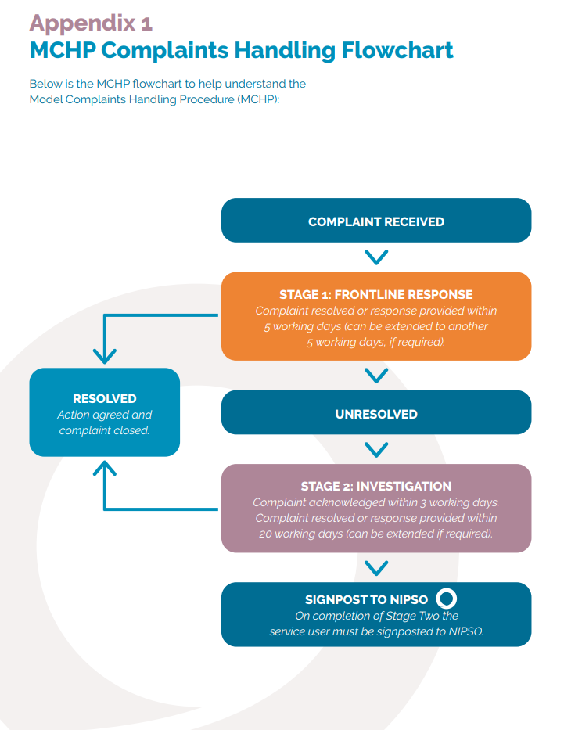

Notting Hill Medical Practice
Complaints Information Sheet

If you have a complaint or are concerned about the services or treatment you have received from the doctors or any of the staff working in our practice, please let us know. We operate a complaints procedure to deal with any complaints which meets the criteria agreed for Health & Social Care Services and Model Complaints Handling Procedure (MCHP)

Who can complain?

Any person can complain about any matter connected with the provision of services provided by practice. Complaints may be made by:

- a patient or client;
- former patients, clients or visitors using HSC services and facilities;
- someone acting on behalf of existing or former patients or clients, providing they have obtained the patient’s or client’s consent;
- parents (or persons with parental responsibility) on behalf of a child; and
- any appropriate person in respect of a patient or client who has died e.g. the next of kin.

Consent

All our staff are aware of their legal and ethical duty to protect the confidentiality of patients. These legal requirements are set out in the Data Protection Act 1998 and the Human Rights Act 1998.

Complaints by a third party should be made with the written consent of the individual concerned.
There will be situations where it is not possible to obtain consent, such as:

- where the individual is a child and not of sufficient age or understanding to make a complaint on their own behalf
- where the individual is incapable (for example, rendered unconscious due to an accident; judgement impaired by learning disability, mental illness, brain injury or serious communication problems)
- where the subject of the complaint is deceased

How can you complain?

Hopefully most problems can be sorted out easily and quickly, often when they arise and with the person concerned. If this is not possible, and you wish to formally make a complaint, let us know as soon as possible in order that we may find out what happened more easily.

We can however, consider complaints made within six months of the date of discovering the problem, provided this is within twelve months of the incident. If it is clearly reasonable in the circumstances to make a complaint after this and where it is still possible to investigate the facts of the case, we can consider extending this time limit.

If you wish to make a complaint, speak or write to the Practice Manager (Barbara Sawyer). The complaints procedure will be explained to you and you will be given assurance that your concerns are dealt with promptly in an independent and unbiased manner. It will be helpful if you are as specific as possible about your complaint. Please be aware anonimised copies of all written complaints are shared with the HSCB for monitoring purposes.

What Happens Next?

Most problems can be sorted easily and quickly. Complaints will be handled in the following stages:

Stage One – Frontline Response

- Focuses on local, early resolution at the point of service delivery.
- Managed by staff or line managers closest to the issue.
- Aims to resolve the concern within 5 working days.
- The complainant will be informed of the outcome and any actions taken.
- If unresolved or the complainant remains dissatisfied, the complaint progresses to Stage Two.

Stage Two – Full Investigation

- A comprehensive and objective investigation will be undertaken.
- A full written response within 20 working days will normally be provided.
- If this is not achievable, the complainant will receive:
- An explanation for the delay, and
- A revised response date.

In investigating your complaint we aim to:

- Find out what happened and what went wrong
- Enable you to discuss the problem with those concerned, if you would like this.
- Ensure you receive an apology, where this is appropriate.
- Identify what can be done to make sure the problem does not happen again.

What happens if I am unhappy with the outcome?

If you are dissatisfied with our initial response, the Health and Social Care Board offer a local resolution options which you may wish to investigate. Alternatively if you feel that local resolution has been exhausted you can take your complaint to the Northern Ireland Public Services Ombudsman within 6 months of the Practice response. They can be contacted by telephone on 0800 343424 or by writing to: The Northern Ireland Public Services Ombudsman, 33 Wellington Place Belfast, BT1 6HN. Email: nipso@nipso.org.uk

Health and Social Care Board – Honest Broker

We hope that, if you have a concern, that you will use our practice complaints procedure. We believe this will give us the best chance of putting right whatever has gone wrong and an opportunity to improve our practice. However, if you feel unable to raise your complaint directly with us or are dissatisfied with the result of our investigation you can contact the Department of Health Strategic Planning and Performance Group (SPPG) at the address below. The Board can act as an intermediary and help in the resolution of your complaint. One of the SPPG Officers will be happy to discuss the options available to you under the HSC Complaints Procedure and contacted as outlined below:

Complaints Office
Department of Health Strategic Planning and Performance Group
12-22 Linenhall Street
Belfast
BT2 8BS
Tel: 02895363893
Email: complaints.sppg@hscni.net
Website:
Health and Social Care Online (https://www.nidirect.gov.uk//online.hscni.net/)

Patient Client Council - Advocacy

Patient and Client Council can provide free and confidential advice, information and help you to make a complaint. This might include help with writing letters, making telephone calls and supporting you at any meetings they might need to attend. More information on the services provided by the patient and client council is available from the Council directly. Contact details are below:

Patient Client Council
2nd Floor, Central House
79 Chichester Street
Belfast BT1 4JE
Tel: 0800 917 0222 Web: http://www.patientclientcouncil.hscni.net

